Car Sharing Data Analysis Using SQL
Project Files: Google Drive

1. Introduction
This project focuses on analysing a car-sharing dataset containing hourly records of car rental demand from January 2017 to August 2018. The analysis involved data cleaning, transformation, normalization, database creation, table relationships, and SQL-based analysis. The main objective was to identify patterns in car-sharing demand and examine how time, temperature, weather, humidity and wind speed relate to demand.

2. Database Structure
The dataset was organized into four related tables: CarSharing_df, time, temperature and weather. The CarSharing_df table contains the main car-sharing records, while the time, temperature and weather tables store related attributes. Foreign-key relationships were created between the tables to allow the data to be queried together.
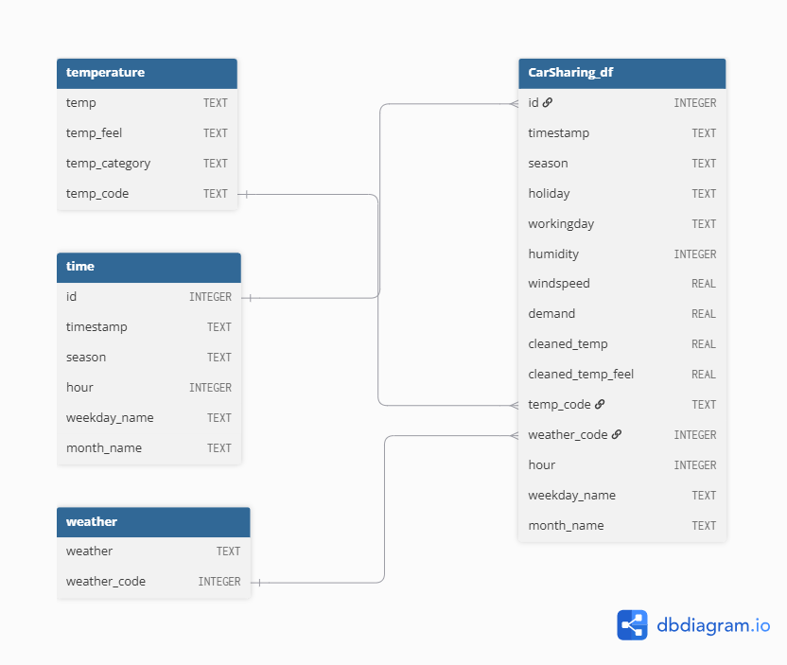
Figure 1: Entity Relationship Diagram of the Car Sharing Database

3. SQL Analysis and Results

3.1 Highest Demand in 2017
Task 6(a) — Highest Demand
Result: The highest individual demand recorded in 2017 occurred on 15 June 2017 at 17:00, with a demand value of approximately 6.4583.
SQL Query – Task 6(a)
-- 6(a) Date and time with the highest demand in 2017

SELECT
timestamp,
demand
FROM CarSharing_df
WHERE strftime('%Y', timestamp) = '2017'
ORDER BY demand DESC
LIMIT 1;

3.2 Highest and Lowest Average Demand
Task 6(b) — Highest and Lowest Average Demand
The combination with the highest average demand was Sunday, July, Fall, with an average demand of approximately 5.7761.
The combination with the lowest average demand was Monday, January, Spring, with an average demand of approximately 3.8840.
SQL Query – Task 6(b)
-- 6(b) Weekday, month and season with highest average demand

SELECT
t.weekday_name,
t.month_name,
t.season,
AVG(c.demand) AS average_demand
FROM CarSharing_df c
JOIN time t
ON c.id = t.id
WHERE strftime('%Y', c.timestamp) = '2017'
GROUP BY
t.weekday_name,
t.month_name,
t.season
ORDER BY average_demand DESC;

-- 6(b) Weekday, month and season with lowest average demand

SELECT
t.weekday_name,
t.month_name,
t.season,
AVG(c.demand) AS average_demand
FROM CarSharing_df c
JOIN time t
ON c.id = t.id
WHERE strftime('%Y', c.timestamp) = '2017'
GROUP BY
t.weekday_name,
t.month_name,
t.season
ORDER BY average_demand ASC;

3.3 Average Demand by Hour
Task 6(c) — Average Demand by Hour
Based on the weekdays identified in Task 6(b), Sunday and Monday were analysed by hour. The highest average demand occurred on Monday at 12:00, with an average demand of approximately 5.6220.
The next highest results were:
- Monday 14:00 — 5.5546
- Sunday 15:00 — 5.5379
SQL Query – Task 6(c)
-- 6(c) Average demand at different hours
-- for the weekdays selected in 6(b)

SELECT
t.weekday_name,
t.hour,
AVG(c.demand) AS average_demand
FROM CarSharing_df c
JOIN time t
ON c.id = t.id
WHERE strftime('%Y', c.timestamp) = '2017'
AND t.weekday_name IN ('Sunday', 'Monday')
GROUP BY
t.weekday_name,
t.hour
ORDER BY average_demand DESC;

4. Weather Analysis

4.1 Temperature
In 2017, Mild temperatures were the most prevalent, with 1,930 records, followed by Hot with 957 records and Cold with 303 records.
SQL Query – Temperature Category Counts
-- 6(d) Temperature category prevalence in 2017

SELECT
temp.temp_category,
COUNT(*) AS number_of_records
FROM CarSharing_df c
JOIN temperature temp
ON c.temp_code = temp.temp_code
JOIN time t
ON c.id = t.id
WHERE strftime('%Y', c.timestamp) = '2017'
GROUP BY temp.temp_category
ORDER BY number_of_records DESC;

4.2 Weather Condition
The most prevalent weather condition in 2017 was Clear or partly cloudy, with 2,114 records. Mist occurred 794 times, while Light snow or rain occurred 282 times.
SQL Query – Weather Condition Counts
-- 6(d) Weather condition prevalence in 2017

SELECT
w.weather,
COUNT(*) AS number_of_records
FROM CarSharing_df c
JOIN weather w
ON c.weather_code = w.weather_code
WHERE strftime('%Y', c.timestamp) = '2017'
GROUP BY w.weather
ORDER BY number_of_records DESC;

4.3 Wind Speed
The highest monthly average wind speed occurred in April, at approximately 18.0041. The lowest monthly average occurred in October, at approximately 11.8051. The highest individual wind speed was recorded in July, at approximately 56.9969.
SQL Query – Monthly Wind Speed
-- 6(d) Monthly wind speed statistics in 2017

SELECT
t.month_name,
AVG(c.windspeed) AS average_wind_speed,
MAX(c.windspeed) AS highest_wind_speed,
MIN(c.windspeed) AS lowest_wind_speed
FROM CarSharing_df c
JOIN time t
ON c.id = t.id
WHERE strftime('%Y', c.timestamp) = '2017'
GROUP BY t.month_name
ORDER BY
CASE t.month_name
WHEN 'January' THEN 1
WHEN 'February' THEN 2
WHEN 'March' THEN 3
WHEN 'April' THEN 4
WHEN 'May' THEN 5
WHEN 'June' THEN 6
WHEN 'July' THEN 7
WHEN 'August' THEN 8
WHEN 'September' THEN 9
WHEN 'October' THEN 10
WHEN 'November' THEN 11
WHEN 'December' THEN 12
END;

4.4 Humidity
The highest monthly average humidity occurred in September, at approximately 70.1962, while the lowest occurred in February, at approximately 47.7331. The lowest recorded humidity was 0 in March, while the highest recorded humidity was 100.
SQL Query – Monthly Humidity
-- 6(d) Monthly humidity statistics in 2017

SELECT
t.month_name,
AVG(c.humidity) AS average_humidity,
MAX(c.humidity) AS highest_humidity,
MIN(c.humidity) AS lowest_humidity
FROM CarSharing_df c
JOIN time t
ON c.id = t.id
WHERE strftime('%Y', c.timestamp) = '2017'
GROUP BY t.month_name
ORDER BY
CASE t.month_name
WHEN 'January' THEN 1
WHEN 'February' THEN 2
WHEN 'March' THEN 3
WHEN 'April' THEN 4
WHEN 'May' THEN 5
WHEN 'June' THEN 6
WHEN 'July' THEN 7
WHEN 'August' THEN 8
WHEN 'September' THEN 9
WHEN 'October' THEN 10
WHEN 'November' THEN 11
WHEN 'December' THEN 12
END;

4.5 Demand by Temperature
Average demand was highest during Hot temperatures, at approximately 5.4324, followed by Mild temperatures at 4.9262 and Cold temperatures at 4.0583.
SQL Query – Average Demand by Temperature
-- 6(d) Average demand by temperature category in 2017

SELECT
temp.temp_category,
AVG(c.demand) AS average_demand
FROM CarSharing_df c
JOIN temperature temp
ON c.temp_code = temp.temp_code
WHERE strftime('%Y', c.timestamp) = '2017'
GROUP BY temp.temp_category
ORDER BY average_demand DESC;

5. Analysis of the Highest-Demand Month
July had the highest average demand in 2017, with an average demand of approximately 5.5001.
SQL Query – Highest Average Demand Month
-- 6(e) Month with the highest average demand in 2017

SELECT
t.month_name,
AVG(c.demand) AS average_demand
FROM CarSharing_df c
JOIN time t
ON c.id = t.id
WHERE strftime('%Y', c.timestamp) = '2017'
GROUP BY t.month_name
ORDER BY average_demand DESC
LIMIT 1;

5.1 Temperature in July
July contained 228 Hot records and 38 Mild records, with no Cold records.
SQL Query – July Temperature Counts
-- 6(e) Temperature category prevalence in July 2017

SELECT
temp.temp_category,
COUNT(*) AS number_of_records
FROM CarSharing_df c
JOIN temperature temp
ON c.temp_code = temp.temp_code
JOIN time t
ON c.id = t.id
WHERE strftime('%Y', c.timestamp) = '2017'
AND t.month_name = 'July'
GROUP BY temp.temp_category
ORDER BY number_of_records DESC;

5.2 Weather in July
The most common weather condition in July was Clear or partly cloudy, with 229 records. Mist occurred 27 times, while Light snow or rain occurred 10 times.
SQL Query – July Weather Counts
-- 6(e) Weather prevalence in July 2017

SELECT
w.weather,
COUNT(*) AS number_of_records
FROM CarSharing_df c
JOIN weather w
ON c.weather_code = w.weather_code
JOIN time t
ON c.id = t.id
WHERE strftime('%Y', c.timestamp) = '2017'
AND t.month_name = 'July'
GROUP BY w.weather
ORDER BY number_of_records DESC;

5.3 Wind Speed in July
The average wind speed was approximately 13.4676, with a maximum of 56.9969 and a minimum of 0.
SQL Query – July Wind Speed
-- 6(e) Wind speed statistics for July 2017

SELECT
AVG(c.windspeed) AS average_wind_speed,
MAX(c.windspeed) AS highest_wind_speed,
MIN(c.windspeed) AS lowest_wind_speed
FROM CarSharing_df c
JOIN time t
ON c.id = t.id
WHERE strftime('%Y', c.timestamp) = '2017'
AND t.month_name = 'July';

5.4 Humidity in July
The average humidity was approximately 53.6604, with a maximum of 94 and a minimum of 17.
SQL Query – July Humidity
-- 6(e) Humidity statistics for July 2017

SELECT
AVG(c.humidity) AS average_humidity,
MAX(c.humidity) AS highest_humidity,
MIN(c.humidity) AS lowest_humidity
FROM CarSharing_df c
JOIN time t
ON c.id = t.id
WHERE strftime('%Y', c.timestamp) = '2017'
AND t.month_name = 'July';

5.5 Demand by Temperature in July
Within July, Mild temperatures had the highest average demand at approximately 5.5781, followed by Hot temperatures at approximately 5.4871.
SQL Query – July Demand by Temperature
-- 6(e) Average demand by temperature category in July 2017

SELECT
temp.temp_category,
AVG(c.demand) AS average_demand
FROM CarSharing_df c
JOIN temperature temp
ON c.temp_code = temp.temp_code
JOIN time t
ON c.id = t.id
WHERE strftime('%Y', c.timestamp) = '2017'
AND t.month_name = 'July'
GROUP BY temp.temp_category
ORDER BY average_demand DESC;

6. Conclusion
The SQL analysis provided useful insights into car-sharing demand during 2017. Demand varied according to time, temperature and weather conditions. July had the highest average monthly demand, while mild temperatures were the most common overall. Clear or partly cloudy weather was also the dominant weather condition. The analysis demonstrates how SQL can be used to organize, query and interpret a relational dataset to support data-driven decision making.

